Advanced Training in Integrating Clinical Assessment of Attachment into PCIT Coaching

July 22, 23, & 24, 2024
VIRTUAL TRAINING
Beth Troutman, Ph.D., ABPP
University of Iowa Carver College of Medicine

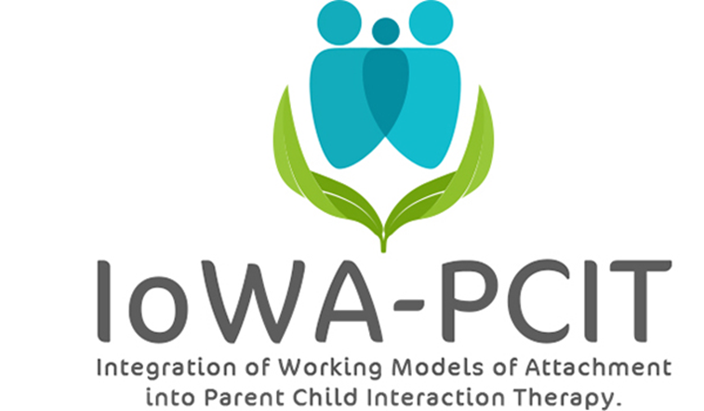

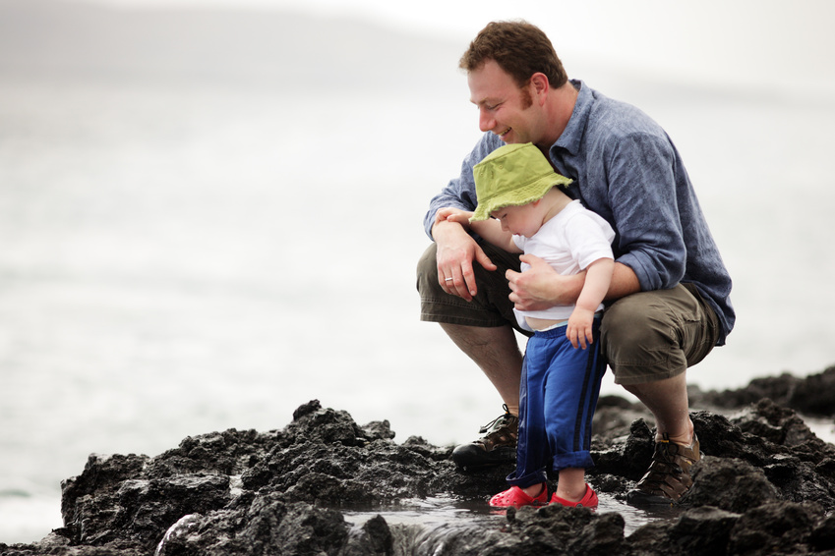
Description of workshop: This workshop will provide IoWA-PCIT therapists with additional training in applying attachment theory to their work with children and families. Participants will have an opportunity to review and recalibrate observations of secure and insecure attachment and discuss how to incorporate these observations into their PCIT coaching. In addition, the workshop will cover adult working models of attachment. We will explore how adult working models of attachment can inform PCIT coaching – including how understanding therapists’ working models of attachment can inform therapeutic interactions.
About the trainer: Beth Troutman, Ph.D., ABPP has been studying attachment theory for the past 35 years. Dr. Troutman’s training in attachment theory includes training in evidence-based assessments and interventions based on attachment theory at the University of Iowa, the University of Minnesota, the University of Amsterdam, the University of Quebec at Montreal, Tulane University, and Marycliff Institute.
Dr. Troutman’s research on attachment and infant mental health has been published in peer-reviewed developmental and clinical journals and presented at national and international meetings. Her book, Integrating Behaviorism and Attachment Theory in Parent Coaching, published in 2015, has been widely read by researchers and mental health providers. The Korean translation of this book was published in 2019. Attachment-Informed Parent Coaching was published in 2022.

Advanced Training in Integrating Clinical Assessment of Attachment into PCIT Coaching
July 22, 23, & 24, 2024
VIRTUAL TRAINING
MUST HAVE COMPLETED IoWA-PCIT TRAINING PART I OR ATTACHMENT FOR PCIT THERAPISTS
PLEASE PRINT LEGIBLY—THANK YOU!
Name:
Credentials (e.g. LISW, LMHC, MSW, PhD):
Organization:
Address:
City: State: Zip:
Day Phone: Fax:
Email:
REGISTRATION FEE: $750.00 per person | PAYMENT
- Includes:  - VIRTUAL sessions from 9:00 AM to 4:00 PM CST on July 22, 23, & 24, 2024  - Attachment-Informed Parent Coaching book | - Registration is complete when form and fees are received.  - Refunds will not be available for registered participants.  - Mail registration and payment (check or money order) to:  ATTN: Beth Troutman  1-182 Medical Education Building  Psychiatry Research  University of Iowa Carver College of Medicine  Iowa City, IA 52242-1057  - Check payable to:  University of Iowa
MEETING LOCATION
Meetings will be held over ZOOM. ZOOM link will be provided following registration.

For questions contact Beth Troutman: beth-troutman@uiowa.edu
CEUS
Attendance is intended to meet the criteria for 15 hours of continuing education for Behavioral Science; Psychology; and Social Work. Certificate of attendance will be provided.

